Tranfer char of nmos

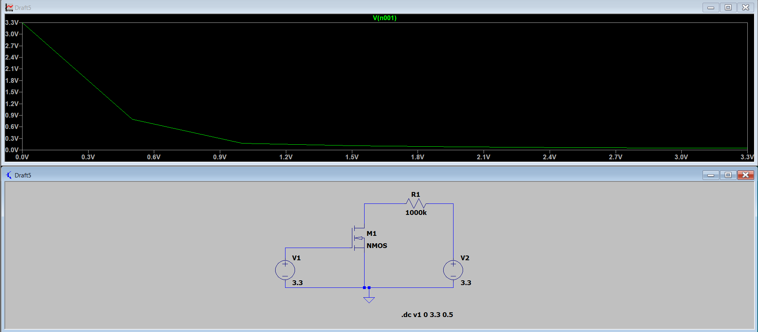

Ip op waveform of nmos resistive load inverter
